21 Brancaster Lane,
Purley,
Surrey
CR8 1HJ
Tel: 020 8660 2529
Mob: 07804252360
Email: margaret@wylie.org.uk

TRAINING: Manchester Poly School Of Theatre 1975-78
Spotlight View Pin: 1890-1230-9936
TELEVISION
Strange But True Cynthia Gisby LWT

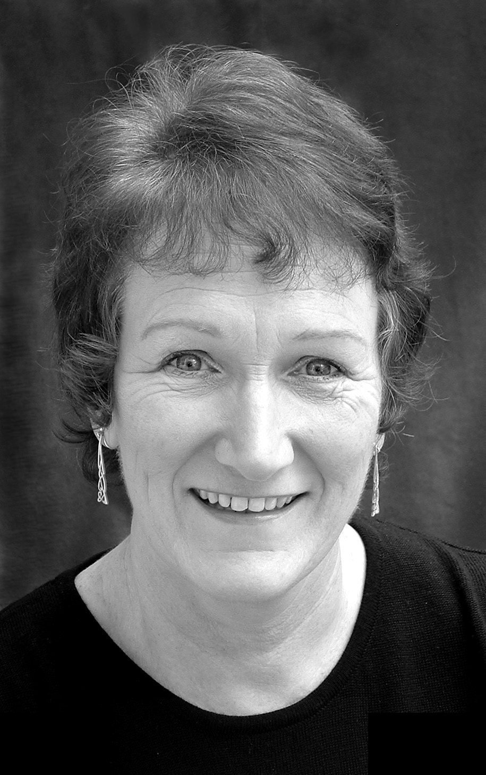
Get Me To The Crem On Time Dr Frank BBC/BFI
Michael Winner’s True Crimes Witness LWT
The Bill Witness Thames
Like Father Like Son Mam BBC
Children’s Ward Physio Granada
Crime Watch Pauline Guest BBC
Wyatt’s Watchdogs Hilda Wood BBC
Coronation Street Mrs Kenworthy Granada
London’s Burning Ward Sister LWT
First Among Equals Conservatives Chairwoman Granada
Come Into The Parlour Maureen Brady Tyne Tees
Coming Home Miss Rothwell BBC
Innes Book Of Records Mrs Nobby Normal BBC
Our John Willie Emma Steel BBC
FILM AND VIDEO
In The Bedroom Christian Dines Layman Films
Irongate Sean Cronin Magnificent Films
‘HELP’ Stephanie Adams Fulwell73
Facing Fears Mavis Ravensbourne
Fighting Arizona Mum Pretzel Films
Looking For Love Complaining Neighbour Devilishly Handsome Prods
The Scarred Maria IFSW
The Brief Encounter Sara’s Aunt LFA/Club Panico
Hidden Agenda DPP’s Secretary Initial Films
Sophie Nurse LIFS
Perceptions Teacher NCAB
Finance Video 1& 2 Managing Director Red Taxi
THEATRE
Night Of the Umbrellas(4 One Act plays)Various Lion and Unicorn
A Novel Approach and Four O’Clock Writer and Steph Etcetra Theatre
Tinned Goods Brenda Kickuptheartsfestival
Relatively Speaking Sheila Durham T.C.
A Taste Of Honey Helen Durham T.C.
The Tinder Box Voluptua –the witch Durham T.C.
The Ballad Of Halo Jones Brina In The Red T.C.
Who Killed Monica Britt Monica Britt Corner Theatre
In Preparation Jesus Christ ZAP T.C.
Differences K-The Different One ZAP T.C.
Sir Gawain & the Green Knight The Green Knight ZAP T.C.
HenryVI Part I Hotspur ZAP T.C.
W.C.Fields Returns O.K! Sharon Emperor T.C.
Hitler In Liverpool Bridget Hitler Gate T.C.
One Orange For The Baby Ruth Gate T.C.
Sink Or Swim Tramp Lyric Theatre
A Trick To Catch The Old One Lady Lucre Wayward Players

PLUS: Commercials, Corporate, Roleplay,Rehearsed Readings Voice-Overs, Music Hall, Radio. SKILLS: Driver, Cyclist, Swimmer, Skiier, Dog Handler. Accents Geordie, Scouse, Northern

